**How to carry out Measurement 1**:

Foramen Magnum Introduction: Bipedalism is a unique trait to hominins and clearly sets us apart from the modern-day animal kingdom. It is certain that early hominins were walking as evidenced at the Laetoli site, a well-preserved series of footprints covered in volcanic ash that’s well dated to 3.6 million years ago.

To compare skulls, scientists use measurements of certain features to calculate indexes. An index is a ratio of one measurement to another. In this case, you will be measuring the distance from the foramen magnum to the opisthiocranion, then compare it to the total skull length.

The index for measuring hominin skulls’ bipedality is known as the opisthion index. The opisthion is the rear most point of the foramen magnum. This index indicates the distance of the foramen magnum from the rearmost point of the cranium relative to the total length of the cranium.

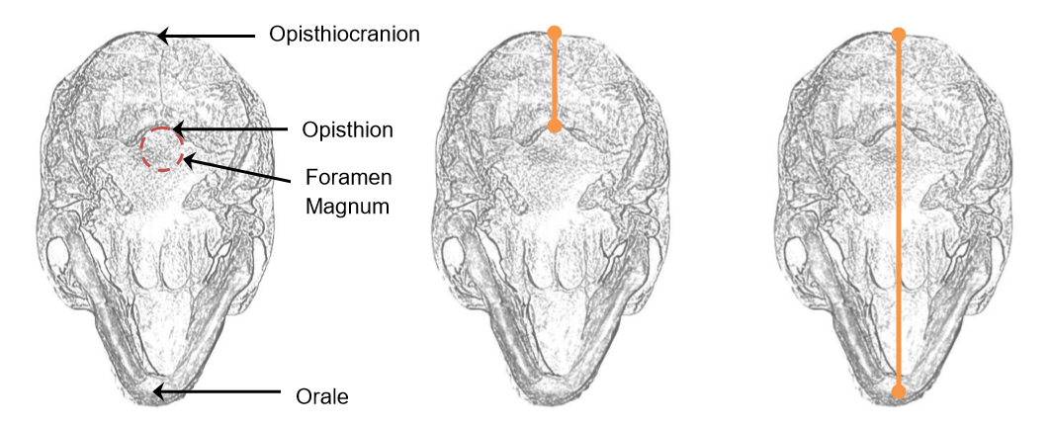An opisthion index value greater than 15 means that the foramen magnum is situated close to the center of the cranium. This position is found in species that **stand upright** and demonstrates bipedalism. An opisthion index less than 15 means the foramen magnum is situated more in the rear of the cranium. This position is found in species that walk on their knuckles or on all four legs.

Guiding question: How does one determine whether a species was bipedal?

**A. Measure**: To determine the opisthion index, follow the steps below and record the value in your table.

* Position the skull so the underside is facing up and the upper jaw line is parallel to the lab desk
* Using the caliper, measure the distance from the opisthocranion to the opisthion, as shown at top right. Record the opisthocranion-opisthion distance in your table.
* Measure from the opisthocranion to the orale, as shown at bottom right. Record the opisthocranion-orale distance in your table.
* To calculate the opisthion index, divide your first measurement by your second measurement. Multiply this number by 100. The answer should be between 0 and 50.

(A / B) x 100 = opisthion index

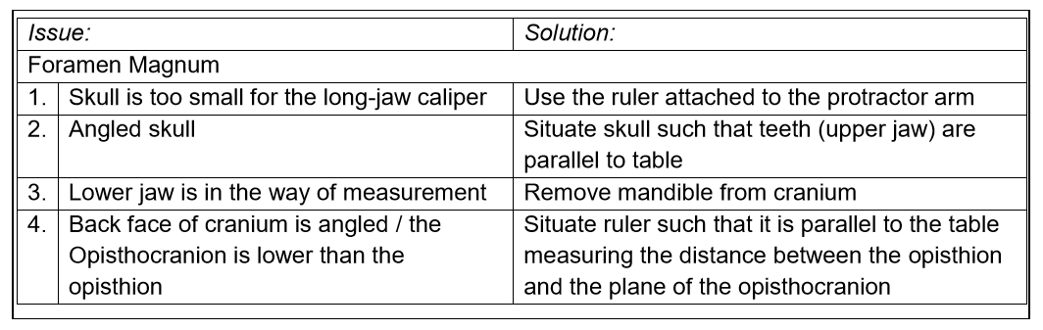

C. Analyze: Examine the opisthion indexes you calculated.

Q. Which of these hominins was potentially not bipedal? A. With an opisthion index of 15, Sahelanthropus tchadensis was a species representing the ancestral quadropedal state, probably occupying an arboreal niche.

Q. Based on the opisthion indexes, which hominin skulls are most similar to the Homo sapiens skull? A. The Neanderthal is closest, but the genus Homo has a significantly larger opisthion index than the australopiths.

Q. Did the genus Australopithecus walk upright? A. The four australopiths were bipedal, but their stature was more hunched. This is also supported by their larger torso length and shorter leg length.